Learning math is fun!  Welcome to Accelerated Geometry B & Algebra II Honors!  Accelerated Geometry B/ Algebra II Honors will include Standards from Accelerated Geometry B and Algebra II. First semester will be comprised of 4 Units: Circles and Volume, Geometric and Algebraic Connections, Applications of Probability, and Quadratics. Second semester will be comprised of 5 Units: Operations with Polynomials, Polynomial Functions, Rational and Radical Relationships, Exponential and Logarithms, and Mathematical Modeling. The course will involve a blend of hands-on learning tasks, technology-based exploration and direct instruction.  Looking forward to a great year! |  |  | Thanks for visiting:  Fun Facts about Ms. Martin!  Education: Ramapo College of NJ, BS Mathematics with Teacher Certification  Goal: To make learning math fun! Love to use math puns / jokes!  Favorite Mathematician: Euclid- founder of Geometry  Favorite Theorem: Pythagorean Theorem- a² + b² = c²! There are hundreds of unique proofs of this theorem and one was written by US president James Garfield.  Interests: I enjoy volunteering with historic older homes. Currently, I am a docent at Bulloch Hall in Roswell, GA. Also, I enjoy the historical content behind the geometry of the high school math curriculum.  Pets: I have two cats that were rescues from the animal shelter their names are Twinkle and Honey!  Let’s Go Cougars!  I  chattahooche high School Mathematics |  |  | chattahooche high School Mathematics  - Ms. Alyssa Martin  - Accelerated Geometry B / Algebra II Honors

How to stay connected?  Feel free to contact me by email at:  Martina10@fultonschools.org  Check out our Class Website at:  msalyssamartin.weebly.com  I will post weekly lesson plans, homework and quiz/test review solutions regularly on the class website!  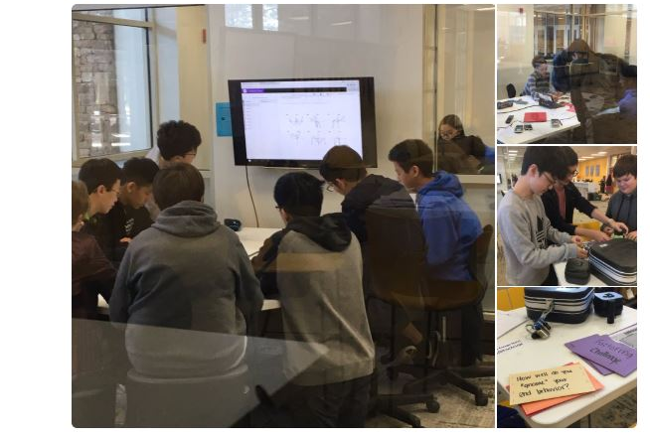 |  |  | Extra Help  ________________________________  “I strongly urge the students to ask for help the moment they experience difficulties. Math builds upon itself – if they do not understand something today, they will not understand tomorrow’s lesson without help. I am available every day before school starting at 7:40 and afterschool.”  Home Access:  A program available to allow parents to keep up with their student’s grades. Parents may check grade summaries. Please, remember that it may take several days to actually enter the grades into the system. |  |  | Course Grading:  Grading Scale: 90-100% A Final Exam* 20% 80-89% B Major 50% 70-79% C Other 10% Below 70% F Minor 20%  * EOC Counts as Semester 1 Final  Homework Policy  Homework is assigned DAILY, which includes Friday nights. Students are expected to write each question, draw all pictures, show all work and correct their own mistakes during reviews. Homework will be checked each day. You will earn grades of a 0%, 50% or 100% determined by completeness. The homework for the week will be averaged to make one assignment grade for the entire week.

