Learning math is fun!  Welcome to GSE GEOMETRY Support!  This is support for the second course in a sequence of courses designed to provide students with a rigorous program of study in mathematics. It includes quadratic functions, transformations in the coordinate plane, similarity, congruence and proofs, right triangle trigonometry, circles and volume, geometric and algebraic connections, and applications of probability. The course will involve hands-on learning tasks, technology-based exploration and direct instruction.  Looking forward to a great year! |  |  | Thanks for visiting:  Fun Facts about Ms. Martin!  Education: Ramapo College of NJ, BS Mathematics with Teacher Certification  Goal: To make learning math fun! Love to use math puns / jokes!  Favorite Mathematician: Euclid- founder of Geometry  Favorite Theorem: Pythagorean Theorem- a² + b² = c²! There are hundreds of unique proofs of this theorem and one was written by US president James Garfield.  Interests: I enjoy volunteering with historic older homes. Currently, I am a docent at Bulloch Hall in Roswell, GA. Also, I enjoy the historical content behind the geometry of the high school math curriculum.  Pets: I have two cats that were rescues from the animal shelter their names are Twinkle and Honey!  Let’s Go Cougars!  chattahooche high School Mathematics |  |  | chattahooche high School Mathematics  - Ms. Martin  - GSE GEOMETRY Support

How to stay connected?  Feel free to contact me by email at:  Martina10@fultonschools.org  Check out our Class Website at:  msalyssamartin.weebly.com  I will post weekly lesson plans, homework and quiz/test review solutions regularly on the class website!  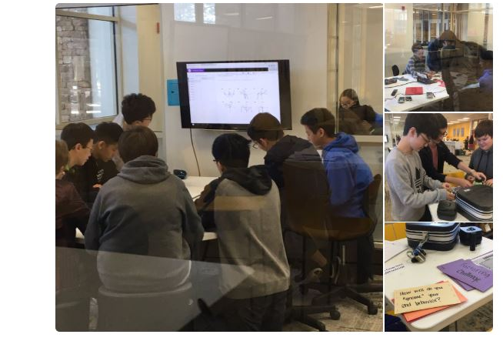 |  |  | Extra Help  ________________________________  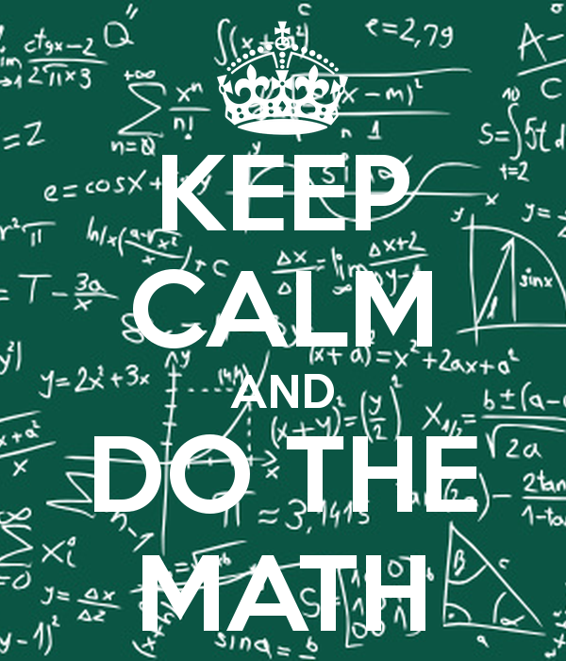  “I strongly urge the students to ask for help the moment they experience difficulties. Math builds upon itself – if they do not understand something today, they will not understand tomorrow’s lesson without help. I am available every day before school starting at 7:40 and afterschool.”  Home Access:  A program available to allow parents to keep up with their student’s grades. Parents may check grade summaries. Please, remember that it may take several days to actually enter the grades into the system. |  |  | Course Grading:  Grading Scale: 90-100% A Final Exam 20% 80-89% B Major 50% 70-79% C Classwork 10% Below 70% F Minor 20%  Classwork Policy  Classwork is assigned daily on the topics covered during the period. Students can use their notes to answer questions that will help them prepare for the quiz / test. Students receive feedback on their classwork assignments in addition to a grade.

